Address assignment

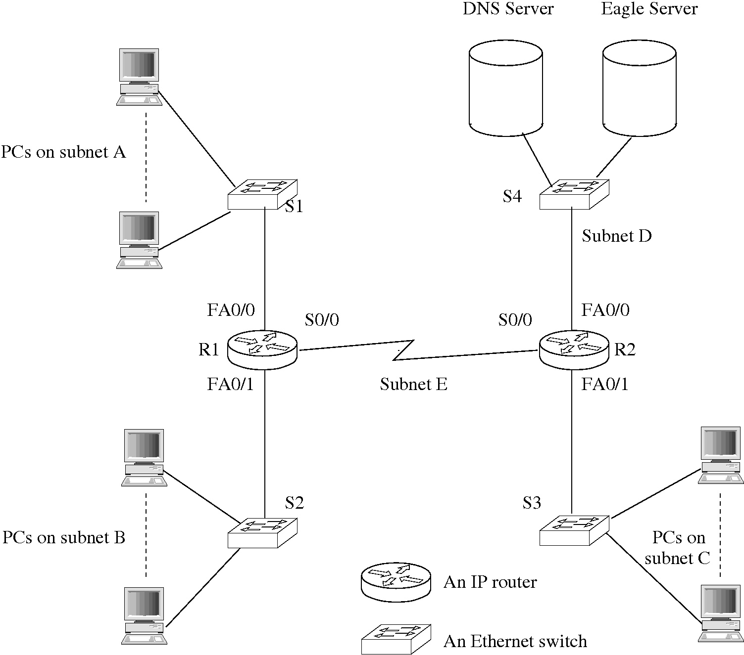
Figure 1 Topology Diagram

Subnet | Network Address | Mask in dotted decimal form (e.g. 255.255.255.0) | Number of hosts including PCs and router interfaces | Number of unused addresses (first and last addresses unusable)
A | 192.168.247.0 | 255.255.255.224 | 23 | 7
B | 192.168.247.32 | 255.255.255.224 | 5 | 25
C | 192.168.247.64 | 255.255.255.224 | 22 | 8
D | 192.168.247.96 | 255.255.255.224 | 3 | 27
E | 192.168.247.128 | 255.255.255.224 | 2 | 28
Table 1 Subnet Details

Device | Interface | IP Address | Subnet mask in dotted decimal form (e.g. 255.255.255.0 for a /24 mask length) | Default gateway
R1  R1 | FA0/0 | 192.168.247.30 | 255.255.255.224 | N/A
 | FA0/1 | 192.168.247.62 | 255.255.255.224 | N/A
 | S0/0 | 192.168.247.158 | 255.255.255.224 | N/A
R2  R2 | FA0/0 | 192.168.247.126 | 255.255.255.224 | N/A
 | FA0/1 | 192.168.247.94 | 255.255.255.224 | N/A
 | S0/0 | 192.168.247.159 | 255.255.255.224 | N/A
1st PC subnet A | NIC | 192.168.247.2 | 255.255.255.224 | 192.168.247.30
Last PC subnet A | NIC | 192.168.247.24 | 255.255.255.224 | 192.168.247.30
1st PC subnet B | NIC | 192.168.247.34 | 255.255.255.224 | 192.168.247.62
Last PC subnet B | NIC | 192.168.247.37 | 255.255.255.224 | 192.168.247.62
1st PC subnet C | NIC | 192.168.247.66 | 255.255.255.224 | 192.168.247.94
Last PC subnet C | NIC | 192.168.247.87 | 255.255.255.224 | 192.168.247.94
DNS server | NIC | 192.168.10.98 | 255.255.255.224 | 192.168.247.126
Eagle Server | NIC | 192.168.10.99 | 255.255.255.224 | 192.168.247.126
Table 2 Addressing Table

Analysis of address space usage

Using a /27 subnet mask, it is possible to have up to 8 subnets, each with 30 available host addresses. There are in fact 32 addresses you could make with the 5 bits used (2^5=32), however the first and last addresses are the network and broadcast address, respectively. I feel that I have used the address space efficiently; I have separated the routers and PCs within subnets, which would allow for expansion, keeping addresses in a logical order. However, it would be easier to facilitate future expansion of the network if I had used variable length subnet masking. This is essentially further subnetting a subnet to have a different number of available addresses within each subnet; this would allow more addresses free to be used in new subnets but conversely will limit the room for expansion in the existing subnets.

Application Layer services

Post office protocol (or POP) is an application layer protocol used to retrieve emails from an email server, as emails are usually stored on a server for you to retrieve rather than sent directly to your computer. POP can be used to retrieve an email and delete it, retrieve an email and not delete it, check to see if any new emails are on the server or preview the message to see if it is needed. Post office protocol uses the TCP layer to communicate. A server using POP will wait for a connection from a client on TCP port 110. Once connection is established, the server will send a greeting; the sessions is then in the authorisation stage. The client can either send the username and password separately or use the APOP command to confirm its identity. Once authorisation is complete, the session enters the transaction state, where the client can request the server for information. These commands are STAT; LIST; RETR; DELE; NOOP; RSET or QUIT[1]. List will list the messages on the server, you can then retrieve a message from the list using the corresponding number of the desired message. Appropriate responses from the server vary depending on the action you have taken, but they will always begin with either +OK or -ERR depending on whether there was an issue with completing the task or not.
Secure Shell (SSH) is a network protocol for secure communication, providing encryption and authentication. SSH uses the TCP layer as well, awaiting connections on port 22. The server will allow the exchange until an action is taken that requires authentication. The server then lists the possible methods of authentication and the client may attempt these methods in any order, if more than one option is available. An authentication request will include the username, the name of the service you are trying to access, and the authentication method, preceded by 'SSH_MSG_USERAUTH_REQUEST'. If the username doesn't exist, the request will be denied. The cleint can interrupt the authentication process by sending another authentication request, however the previous attempt will be stopped. If the authentication is unsuccessful, the server will send an error message, with the list of other methods you can attempt, as well as a boolean value to show whether the previous attempt was partially successful.
The four methods that can be used for authentication are publickey, password, hostbased and none [2]. You are only able to use none if your username does not require authentication for a particular step; the server will send an accept or reject response to this request. Publickey uses a password activated key on the client computer to generate a signature that can be authenticated by the server. Password uses a basic text password as means of authentication; unsuccessful authentication will result in a failure message, however if the password has expired it can send a message indicating this as well. Host based authentication uses the clients IP and the user name on the client pc to authenticate- this is convenient as you do not need to enter any further information, however it is not recommended for a high security task as it is easy to manipulate this information (through use of a proxy server, for example).

References
[1] J. Meyers, Post Offic Prtotocol- Version 3, IETF RFC 1939, 05/1996 Available from http://www.faqs.org/rfcs/rfc1939.html
[2] T. Ylonen, The Secure Shell (SSH) Authentication Protocol, IETF RFC 4252, 01/2006 Available from http://www.ietf.org/rfc/rfc4252.txt

